**1970smagnetictapedrive**

1970s Magnetic Tape Drive

**A Data Communication Historical Series**

**By Bob Pollard**

**Development of Magnetic Tape Drives:**

Magnetic tape drives have taken a path similar to the disk drive, going from a large seven foot high cabinet to a device that can sit on a desk or be installed in the small computer mainframe that sits on a desk. Storage capacity and speed in addition to the physical size reduction has also improved.

**1970’s Tape Drive:**

The following Illustration describes a 1970’s standalone magnetic tape device (drive). This particular magnetic tape drive is small when it is compared to the RCA magnetic tape drives used with the 1960’s Communications Data Processor, which was theModel 581 Magnetic Tape Station. But if we compare either one of these devices to the present tape drives for a Personal Computer, they are monsters.

A few more specifics not included in the illustration: A 1970’s magnetic tape drive.

* EOF (End of File) is a tape mark written by a program or hardware (electronically). Usually some special character(s) is used and it indicates the end of a valid file on the tape.
* The End of Tape warning indicator will cause all writing or reading to stop since the end of usable tape has been reached. Also the tape will stop since it would unwind off the end of the reel.
* The master reel indicator illuminates when the tape reel has a special ring inserted on the bottom side. This feature will prevent any writing to the tape, which inhibits the destruction or over writing of important information.
* Data are only written in a tape forward direction, although data may be read in either a forward or reverse direction.
* A tape rewind will return the tape to the beginning start point and a rewind usually occurs at a higher speed than a write or read function. Other typical functions:
* A reverse command causes the tape to move in a reverse direction at the normal read and write speed.
* A forward command causes the tape to move in a forward direction at the normal read and write speed.
* A skip or count gaps command causes the tape to move a designated number of gaps.

The packing density of magnetic tape is usually expressed in Bits per Inch (BPI), synonymous with characters per inch, which means the tape drive will pack a designated number of characters per inch of tape. Example:

* 200 BPI
* 556 BPI
* 800 BPI
* 1600 BPI

Some tape drives were designed to handle two different packing densities, such as 556 or 800 BPI, but only one density can be used at a time.

[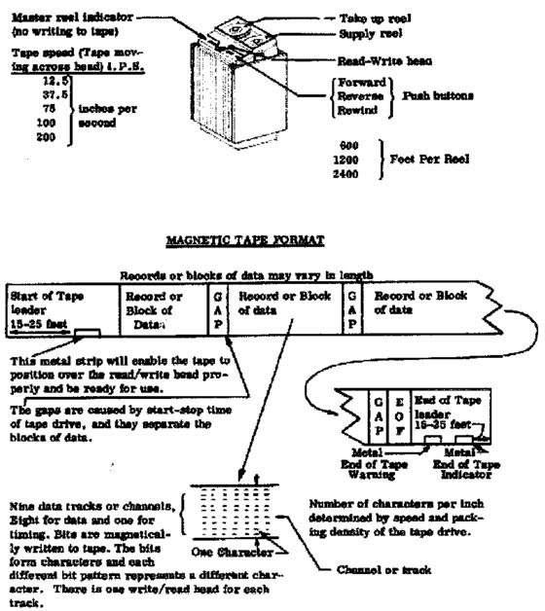](https://sites.google.com/site/mdprcp/MagneticTapeDrive.tif?attredirects=0)

**Modern Tape Drive:**

Present day magnetic tape drives can be placed on a desk and is connected to the CPU through a cable. This small magnetic tape drive uses an eight-millimeter tape similar to the cassette tapes bought at a music store. This device can store, depending on the model, in the neighborhood of 30 to 90 gigabytes (billion bytes) of information. All the controls and tape scanning functions are still required, but the tape formatting and control functions have been modernized and these devices operate at a much higher speed.